ADDRESS COMPONENT

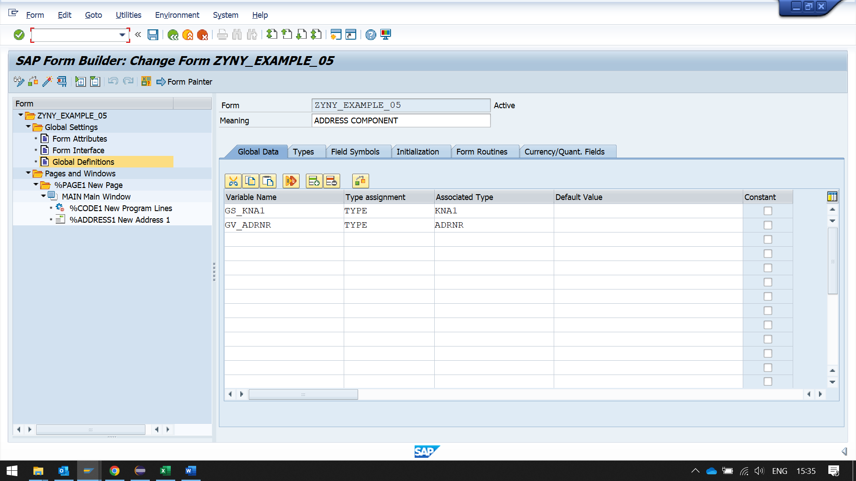

CREATE PROGRAM LINES IN MAIN WINDOW TO WRITE LOGIC 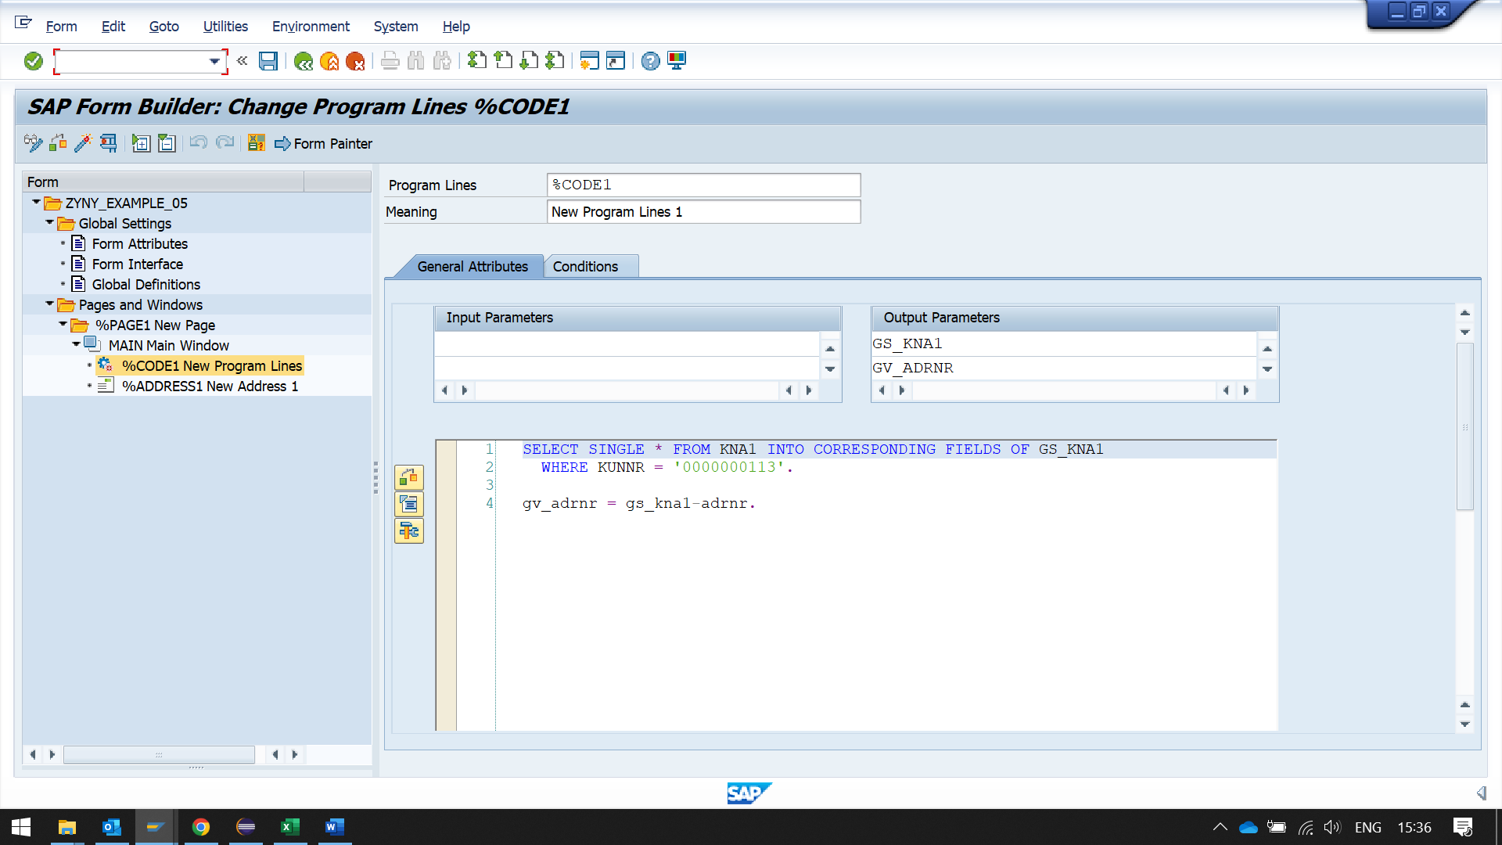SELECT SINGLE * FROM KNA1 INTO CORRESPONDING FIELDS OF GS_KNA1  
  WHERE KUNNR = '0000000113'.  
  
gv_adrnr = gs_kna1-adrnr.

THEN CREATE ADDRESS TO PASS THE DATA

